**Assisted Practice: 2.7 Running Tests on Selenium Grid**

This section will guide you to:

* Run the scripts on Selenium grid

This lab has two subsections, namely:

2.7.1 Running the tests on Selenium grid

2.7.2 Pushing the code to your GitHub repositories

**Step 2.7.1:** Running the Tests on Selenium grid

* Open Eclipse
* Click on **Package** and navigate to **New** --> **Class**
* Give a valid Class name (example: GridTest)
* Check the **public static void main** checkbox and click on **finish**, which will create a blank Java class
* Write the desired capabilities in the class, which looks like

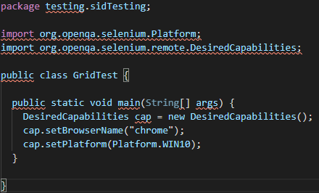

* Start the selenium grid hub in command prompt using **java -jar selenium-server-standalone-3.141.59.jar -role hub** command
* Start the selenium grid node in Command prompt using **java -Dwebdriver.chrome.driver="chromedriver.exe -jar selenium-server-standalone-3.141.59.jar -role node -hub** [**http://localhost:4444/grid/register**](http://localhost:4444/grid/register%5C%E2%80%9D) command
* Go to eclipse and add a statement for remoteWebdriver, which has an implementation of WebDriver, should pass the hub port (http://192.168.1.248:4444/wd/hub), and DesiredCapabilities object as parameters
* Write Selenium code to open the browser and navigate to any web page (example: Google page)

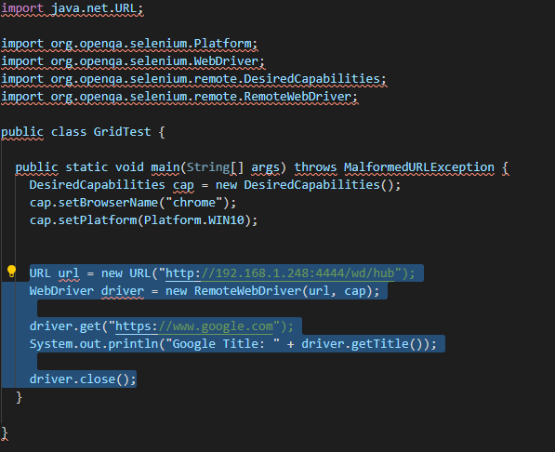

* Execute the Java program by right-clicking on the program and navigating to **Run As**--> **1 Java Application**
* This is how it looks like in Eclipse console

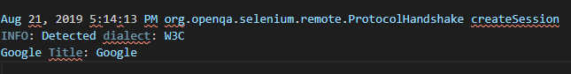

* We can see the capabilities passed through are displayed in both command prompts in server (hub) as well as in clients (node)
* Selenium grid hub in command prompt with desired capabilities looks like

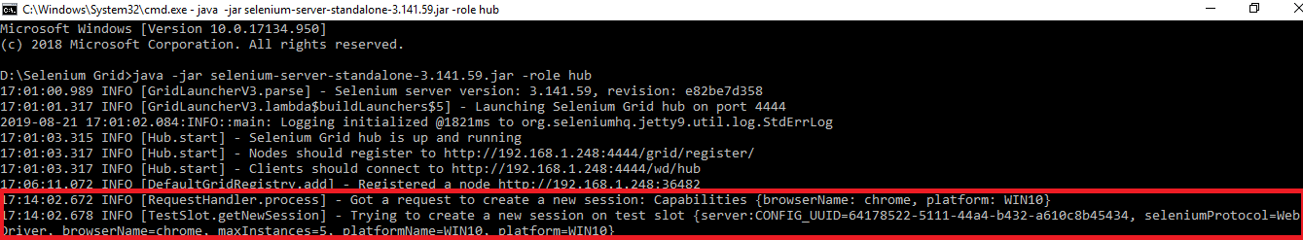

* Selenium grid node in command prompt with desired capabilities looks like

